**Travels Through Germany Deutschland**

**Munich and Regensburg**

**March 2024**

**Mu**

**Munich, Regensburg**

**How do Germans say it**

**Autobahn**: Highway

**Bundestag**: Federal Diet/Parliament

**Bundesstadt**: federal city

**Danke** (daanka) thank you

**Guten Morten** (good morning) or just Morten (Morning)

**Guten** Tag (hello, good day)

**Glockenspiel** (gla-kun-zpell) – clock

**Hofbräuhaus** (host-boy-house) beer hall (in Munich)

**Luftwaffe**: Air Force

**Marientplaz** (square) (Maarian-platz)

**Wirtshauser** (Yust-aus)/beer-garten (beer garden/pub)

**(1) Sites Visited in Munich**

(1) ***Marientplatz****:*

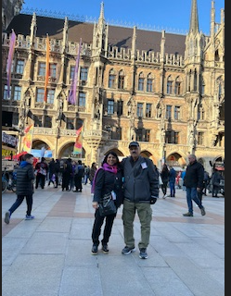 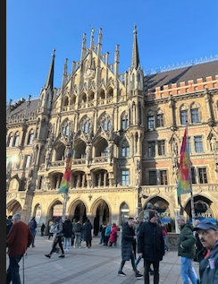 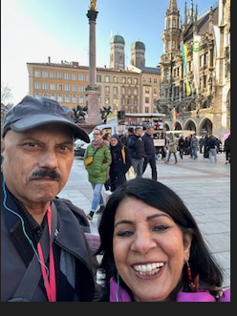

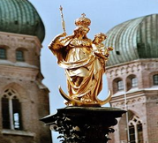 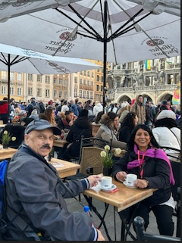 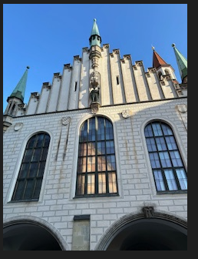

***Patrona Bavarie*** ***Beer Garten at Marienplatz*** ***Old Townhall***

**About Marienplatz** (**maarian-platz**): This is a very vibrant and huge square in Old Town, and forms the cultural heart of Munich, this is the location of the famous Christmas markets, celebrations/protests etc. I loved the energy of the place, people from all over the globe, there were at least 10 demonstrations (Palestine issue, Afghan, Women’s liberation etc.) The city center was founded by Henry the Lion (1158). Maximilian I (archduke Austria, German king, Holy Roman emperor (1493–1519) made his family (Habsburgs), dominant in 16th-cent Europe), he stands on 11-meter-tall column statue that was erected by the public to show their gratitude for him for keeping Munich safe while occupied by Sweden in 30-Yrs War. The center also has a golden statue of Virgin Mary, **Patrona Bavariae**, watching over city/state of Bavaria.

(2) **Glockenspiel** (**gla-kun-zpeell**) English translation Bell set

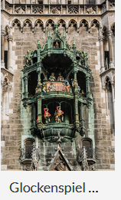 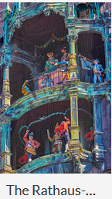

**About Glockenspiel:** Glockenspiel at Munich Rathaus (Town Hall) chimes daily, this is the highlight of the Square. This amazing clock contains **43 bells, 32 figures, perform 2 of Munich’s historical events of 16th cent** for 15 minutes each time. Top half tells story of tournament (1568) to celebrate marriage of Duke Wilhelm V, bottom half portrays Schäfflertanz (cooper's dance). We were able to watch the entire performance that began at 5:00 pm.

***(2) Visiting Medieval town of Regensburg***

**Sites Visited:**

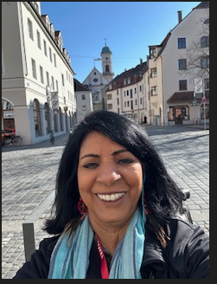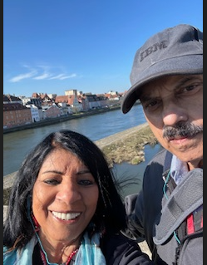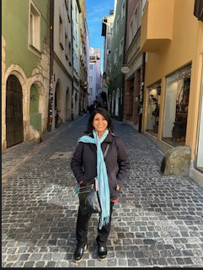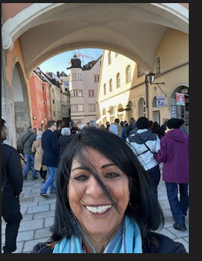

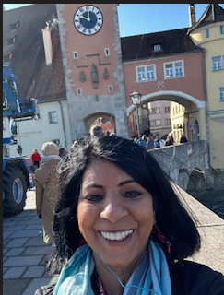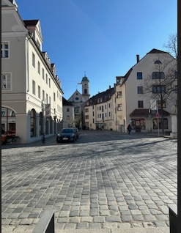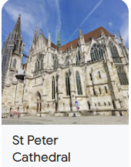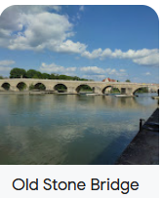

**About Regensburg**: Regensburg, a Bavarian region situated on the Danube and joined by the Regen River (thus the name), boasts a rich history spanning over 2000 years. Located 70 miles northwest of Munich, it is an absolute medieval gem, once the capital of Bavaria. Its medieval center, recognized as a UNESCO World Heritage Site since 2006, is celebrated for its unparalleled preservation and architectural splendor, making it the largest medieval city site north of the Alps. Regensburg holds significant historical importance, serving as a pivotal location for assemblies during the Holy Roman Empire. This was a beautiful day visit out of Munich.

***(3) ABOUT MUNICH*:**

**About Munich**: Southwest of Germany, on banks of River Isar, north of Alps, close to Austria (Vienna). Seat of Bavarian administration, Bavaria’s capital, home to centuries-old buildings, museums - known for its annual **Oktoberfest** celebration**, beer halls** (famed Hofbräuhaus (pronounced: host-boy-house) founded in 1589). In **Altstadt** (pro: **a-il-stad)** (Old Town), Marienplatz square contains the popular **glockenspiel** (**glaa-kun-zspheel**) (clock tower) chimes and reenacts stories from 16th century.

**Munich is Famous for: (1) Home of BMW (**Bavarian Motor Works**) (2) Hofbräuhaus** (Beer hall/gardens) 16th century **(3) Octoberfest (4) Christmas Market**

**Beer Gardens**: Wirtshäuser (pro: yust-aus)- traditional Bavarian pubs, Biergärten (beer gardens) popular fixture in Munich's gastronomic landscape - central to city's culture, melting pot for all people, beer gardens can be small/intimate but also large enough with thousands of seats. **Role of Beer in early life of Munich**: Munich suffered from poor water sanitation and in 1700s beer came to be regarded as the fifth element. Soldiers stationed in Munich were granted a daily allowance for beer in early 1840s. By 1850s beer became staple food for Munich's working and lower classes. Since Middle Ages beer had been regarded as nutritious liquid bread in Bavaria. Beer was essential in maintaining public health in Munich 40,000 residents relied primarily on beer for their nutrition.

**Lang**: German/ Bavarian dialects.

**Immigration**:Turks - largest group of foreigners, also Croats, Russian. Munich has largest Uyghur population (about 800) whole of Germany has 1,600 people of Uyghur diaspora. Many fled to Munich due to crackdown by the Chinese government and are exiled in Munich. Munich is also home to World Uyghur Congress, an international organization of exiled Uyghurs.

**History of Munich**: **1158**: Duke of Saxony and Bavaria Henry the Lion founded town of Munich. **1300s**: Duke Louis IV, native of Munich, was elected German king in 1314 and crowned as Holy Roman Emperor in 1328. He strengthened city's position by granting it salt monopoly, meant additional income. In 1349, Black Death ravaged Munich and Bavaria. **1500s**: William V had the Hofbräuhaus built in 1589, it became prototype for beer halls across Munich. **1700s**: Under regency of Bavarian electors, Munich became center of Baroque life, but suffered under Habsburg occupations in 1704 and 1742. **1800s**: October 1810 beer festival was held on meadows outside Munich to commemorate wedding of crown prince, celebrations developed into Munich's annual Oktoberfest. **1900s**: Afte WW1 a short lived Bavarian Soviet Republic was proclaimed. 1920s, Munich became home to political factions, e.g. the Nazi Party. After Nazis' rise to power, Munich was declared their "Capital of the Movement". City was heavily bombed during WW2, but was restored. After end of postwar American occupation in 1949, there was a great increase in population and economic power. **Today** Munich - global center of technology, finance, tourism, with high standard of living.

***(4) About Regensburg****:*

**History of Regensburg**: The roots of Regensburg trace back to a Celtic settlement, which later evolved into a Roman outpost. Following the partition of the Carolingian Empire in 843, the city became the seat of the Eastern Frankish ruler, Louis the German. Two years later, it became a focal point for Christianization of the Czechs when Bohemian princes arrived here for baptism, leaving a lasting impact on the cultural history of the Czech lands.

In 1146, the iconic Stone Bridge spanning the Danube was opened, heralding the beginning of Regensburg's golden age. This bridge facilitated international trade routes between Northern Europe and Venice, propelling the city into prominence as a hub for wealthy trading families. During this period, Regensburg flourished as a cultural center renowned for its exquisite goldwork and fabrics.

Despite its illustrious past, Regensburg also bore witness to darker times. From 1945 to 1949, it served as the site of the largest displaced persons camps in Germany. At its peak, the Ganghofersiedlung workers' district housed thousands of Ukrainian and other refugees and displaced persons.

Today, Regensburg's historical legacy is palpable in its landmarks, including the 12th-century Stone Bridge and the Gothic masterpiece of the Regensburg Cathedral. Additionally, the Parthenon replica known as Walhalla stands as a tribute to illustrious Germans, enriching the city's cultural tapestry.

***(5) Personal Experiences from this visit:***

**Arrival in Munich and Day 1**: Our direct United airlines flight from Washington Dulles Int’l departing March 7 at 5:20 pm brought us to Munich’s Franz Joseh Strauss airport at 7:40 am next morning. Finding our way to Terminal 1 to meet Tour Director Mr. Arne Schmidt was a 20-minute easy walk. Our pick-up time from the airport by the Tour Company (Trafalgar) was at 10:00 am giving us time to enjoy coffee and watch the Munich airport crowd.

Our German Tour director came promptly at 10:00 am, to take us to our Holiday Inn Munich Westpark hotel. We were provided luggage tags to identify as part of the Trafalgar Tour group.

Checking in at the hotel was easy as everything was pre-arranged by Trafalgar. Outside the hotel elevator each day was an itinerary for the Trafalgar hotel guests, it informed us of the times for: breakfast, bus departures, and whether we were checking out next morning or spending the next night at the hotel.

At 3:30 pm we were scheduled to meet our other fellow travelers in the hotel lobby. In meantime we searched for some lunch places, hotel staff informed us that we will find authentic Bavarian restaurants in walking distance, walking around we popped inside a few beer gardens but none of them served lunch, we finally stopped in the German grocery store called Lidl (several branches in the U.S. also) and bought 2 savory pies ‘Zwiebelkuchen’, filled with cheese and onions, to go with the coffee from next door coffee shop.

At 3:30 pm we departed the hotel to board our coach, to launch our journey into the Imperial Europe. Our Welcome to Munich was through the city orientation tour. The bus brought us to the **Maximillian Strasse** (Maximillian Street), resembling the Rodeo Drive in Beverly Hills CA, with high end, name brand shops. This was a sophisticated part of Munich; city tour quickly immersed us in the sights and sounds of this Bavarian capital. In the middle of the street was the Max-monument, with four pillars of men holding up the column. Next, we were at Marienplatz, the vibrant center of Munich city life since the 12th century. This was an amazing place, loved the energy of the place, with people from all over the globe.

Looking for a restroom was a challenge throughout our time in Central Europe, not only one is required to pay to use the facilities, but such facilities are hard to locate, always two or three flights down, totally invisible, underground. After searching for one and fearing going up/down 2 flights of stairs, we decided to check a restaurant with the restrooms, this was a better option.

We sat at the beer Garten right outside the Glockenspiel to be able to witness the show at 5:00 pm, this was perfect. This was a lively place full of protesters demonstrating for Palestine, Afghanistan, women’s libs, whatever. But all was peaceful, police was present for security only. Our tour group was to meet by the Fischbrunnen (fish fountain) a common meeting place, near this vibrant square.

Our buffet-style dinner, a Welcome Reception was, conveniently organized at our hotel.

**Day 2**: Our tours, in each city, began after breakfast in the hotel. On Day 2 we journeyed to Medieval Regensburg, later reaching Prague. We headed north from Munich covering a distance of 80 miles in a little more than an hour. Visit to this UNESCO World Heritage was precious, a lovely quaint town on the Danube River. After being dropped off from the bus, near a railway locomotive, we were on our own until the meeting time back on the bus. This was enough time to find lunch and coffee, stroll on the 12th century Stone Bridge, stop by the 13th century Regensburg Cathedral, a wonderfully-designed Gothic landmark. It was always challenging to find our way back to the bus, but one end of the stone bridge was our marker for where the bus had dropped us. It was a precious afternoon in Regensburg, with time to buy souvenirs.

A three-hour drive from Regensburg took us to the border of Czechia (Czech Republic) to enter Prague.

***(6) About Germany***

**Berlin** (Capital) **Frankfurt** (financial hub) **Munich** capital of Bavaria, cultural capital

In Central Europe, bordered by: Denmark (N), Austria, Switzerland (S), Poland, Czech Rep (East), France, Luxemburg, Belgium, Netherland (W).

**Mountain**: Alps (S).

**Seas**: Baltic and N. Sea to North).

**Rivers**: Rhine, Danube, Elbe.

**National Parks**: Black Forest, Bavarian Forest.