http://travels.onmason.com/2024/08/10/sudhas-travelogue-on-austria/

Travels Through Austria:
Vienna, Salzburg
March 2024

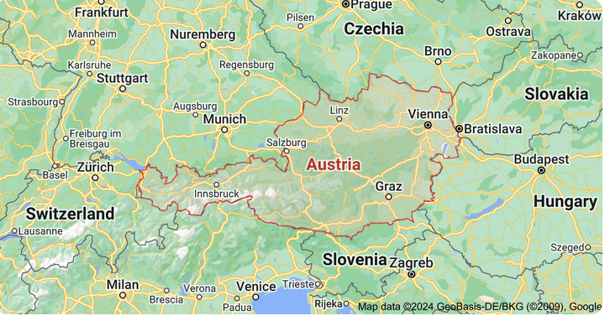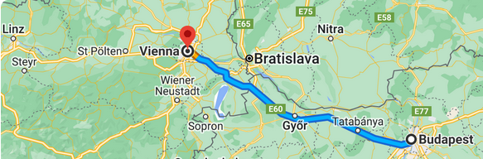

Arrival into Austria’s capital of Vienna from Hungary’s capital of Budapest, was a 3-hours coach trip, which brought us to Vienna in later part of the evening, providing a leisurely evening to indulge on our own. Our two-nights stay in Vienna was at Hilton Danube Waterfront. Set on the waterfront, this hotel had breathtaking river views, all parts of the hotel provided a view of the waterfront, including the fitness center, the restaurant, the bar and our own room, with an entrance to the waterfront from the inside of the hotel.
- Our Stay in Vienna

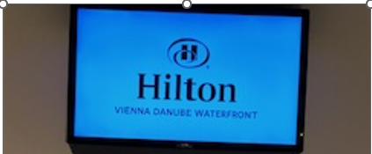
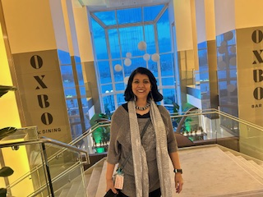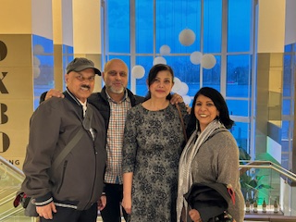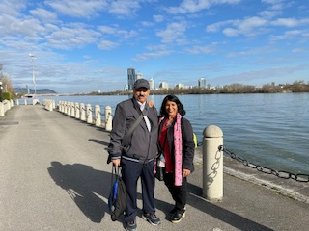

Meeting our Austria family at our hotel for the evening Waterfront from Hotel

Dinner outing with the family at
Westfield Donau Zentrum Mall
: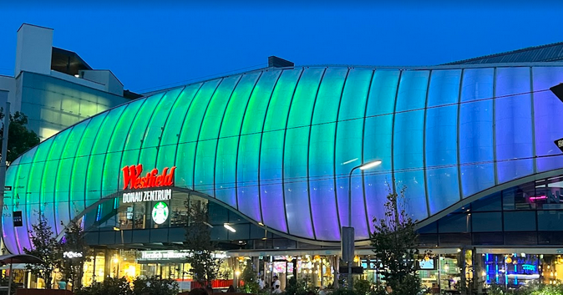
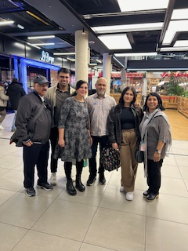
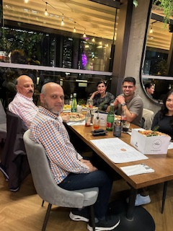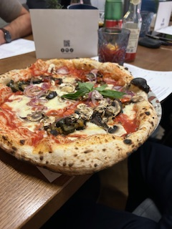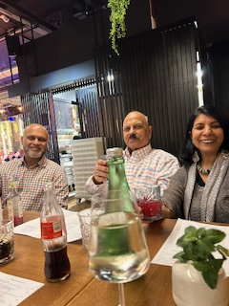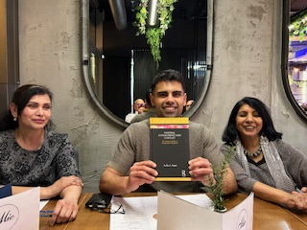

(2) First Full day in Vienna

Grand State Opera House Hofburg Palace
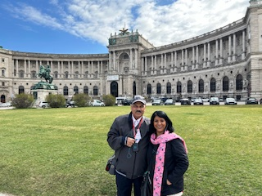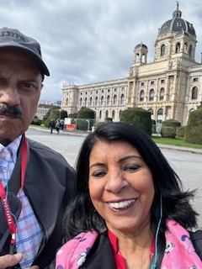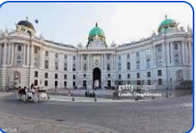

After touring with the group to see the Grand Opera House, the Hofburg Palace, the Ringstrasse (a beautiful sweeping boulevard), once again, we had an afternoon on our own and, once again, met-up with our Austria family, this time near the iconic Saint Stephen’s Cathedral, our tour groups members had also dispersed to explore on their own.

>>>>>> St. Stephen’s Cathedral >>>>>> Outside Café Sluka
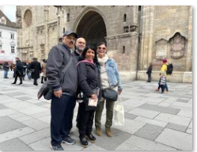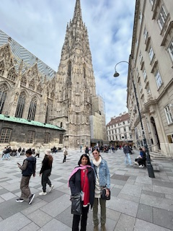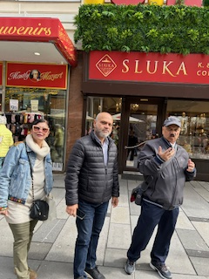

Our coffee stop with the family was at Café Aida (home of the Viennese coffee)
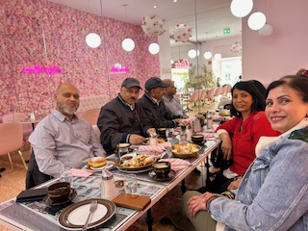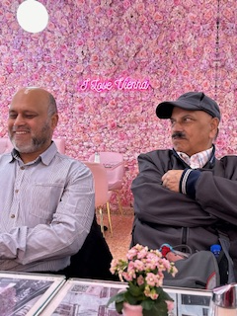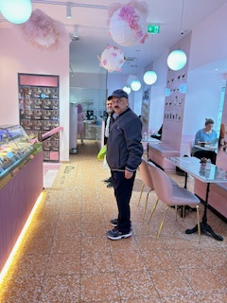

The evening was reserved for Dinner and Viennese Concert with our Tour members
The dinner was at a renowned and historic restaurant called, Marchfelderhof, in Deutsch Wagram, a charming village in the Gänserndorf District of Vienna, 14 miles from Vienna city center. It was an extraordinary and truly an imperial experience, the staff rolled out the red carpet, starting from our tour bus to the restaurant entrance, escorting us to the restaurant with a violin serenade, making the evening exceptionally memorable. A magical must-see restaurant, since the time of Napolean, patrons who have visited the place include King Constantine of Greece, King Faruk of Egypt, Liz Taylor, and now us!

Pics: With Tour: Dinner at Restaurant Marchfelderhof
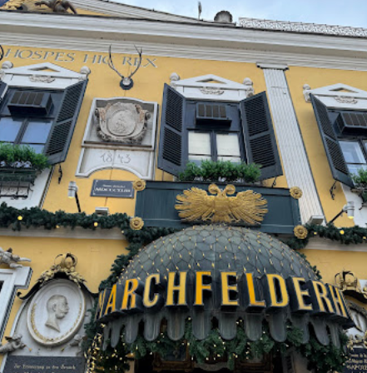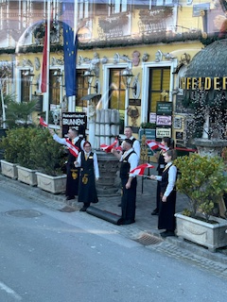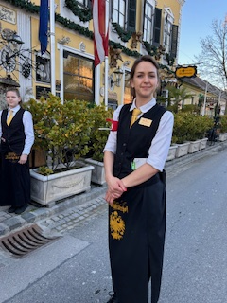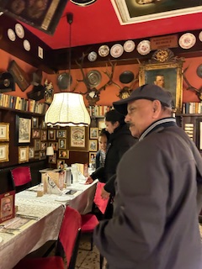

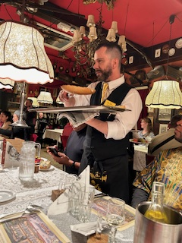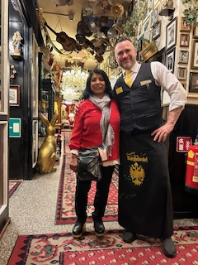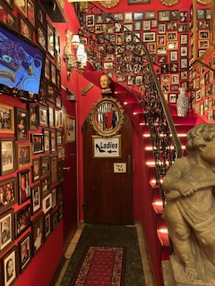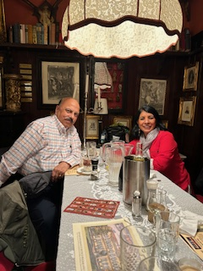

With Tour: Attending the Vienna Supreme Concert, at Palais Eschenbach
Later part of the evening was devoted to attending the absolutely Must Do One Thing while visiting Vienna, was attending the Classical Vienna Supreme Concert, at the Palais Eschenbach. With our A class tickets we enjoyed the full concert, listening to the music of Beethoven, Mozart, Strauss and Vivaldi, an unforgettable treat built into our Imperial Tour.
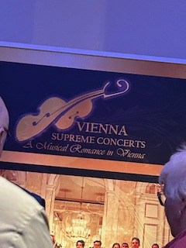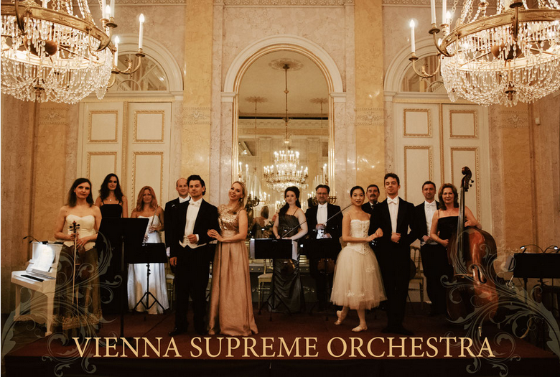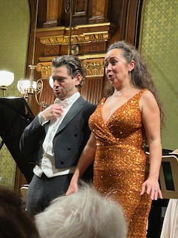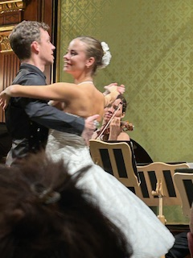

(3) Next city: SALZBURG
(birthplace of Mozart)
Pics: Old Town Salzburg
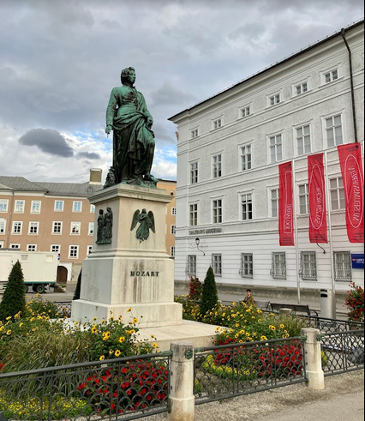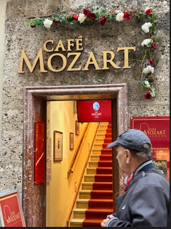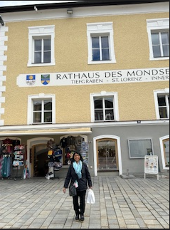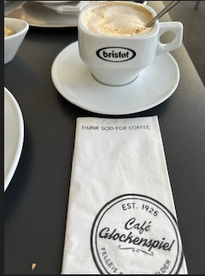
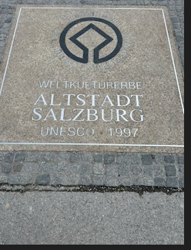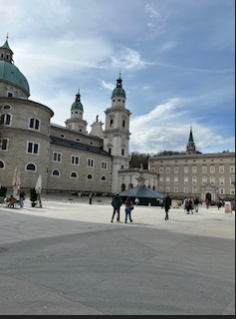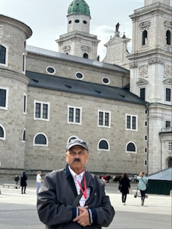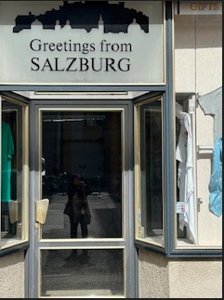
pics above: The Salzburg Residens/Alte Residenz (Old), is a palace located at Domplatz and Residenzplatz in the historic center (Altstadt) of Salzburg. Seeing the downtown Salzburg meant a leisurely walk with a local specialist.

Pics: In the Alps
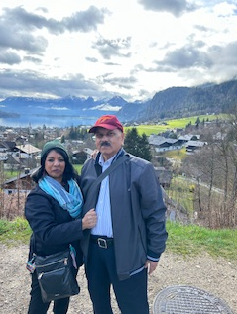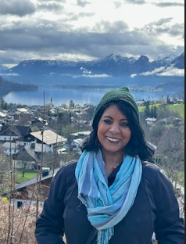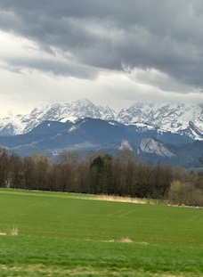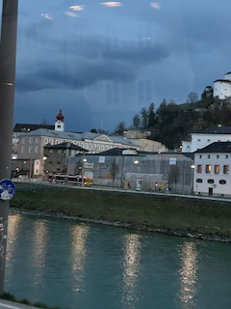
pics above: St. Gilgen (Central Bavaria) is a village by Lake Wolfgang in Salzburg, pics show Bavarian Alps in the background.

Markplatz Mondsee Basilicia:
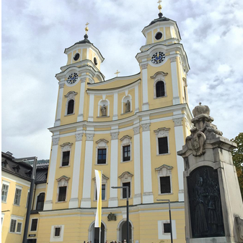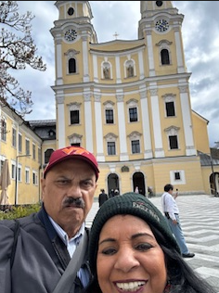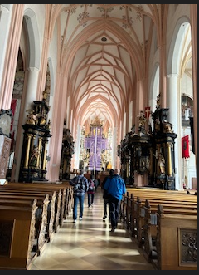
pics above: The Benedictine Abbey Noonberg is located on the eastern foothills of the Festungsberg beneath the Salzburg Fortress.
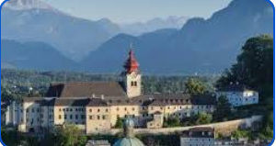
Noonberg Abbey (the site of the movie Sound of Music):

(4) Spending time with fellow travelers
We were a group of 30 travelers that launched our exploration of the Imperial Europe, from Munich with a two-day stop, proceeding to the Czech Republic, Slovakia, Hungary, with Austria being our last stop on this 8-day tour.
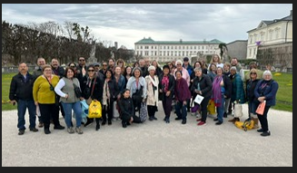
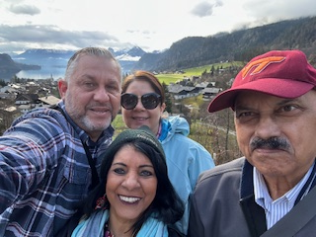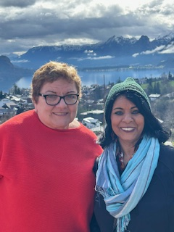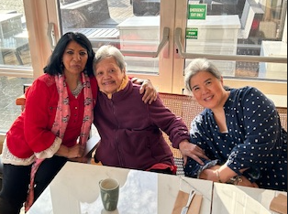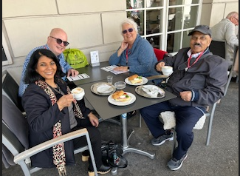
Pics: (1) Family from Puerto Rico (2) Traveler from Australia (3) Ninety-seven-year-old grandma from Philippines (4) American family from Philadelphia

(5) About Sites Visited in Vienna:

(1) Grand State Opera House: Located on Vienna’s Ringstrasse boulevard (Ring Road), this is a historic opera house, built in 1860s, in the Renaissance Revival style. Among directors from 1908 until the annexation of Austria by Germany in 1938 was Richard Strauss, the German composer.
(2) St. Stephan’s Cathedral (affectionately called the Steff by locals): This is an architectural gem, the symbol of Vienna and stands in the center of the city, being the country’s most important Gothic building. This impressive structure is the symbol of identity and the reconstruction the Republic after World War 2. Although the construction began in 12th century but its Baroque appearance developed over the succeeding centuries. On the roof of the cathedral the colorful tiles create the Royal double-headed eagle and the coat of arms of the city of Vienna.
(3) Hofburg Palace: This is the former imperial palace of the Habsburg dynasty in Austria, served as the dynasty’s residence for 600 years, built in 13th century and expanded several times afterwards. It also served as the imperial winter residence, as Schönbrunn Palace (other of the Habsburg dynasty residence) was the summer residence. Enjoyed visiting this stunning Baroque architecture, with lavish interiors and beautiful gardens, the Palace serves as one of the most important centers of European history. Aside: Originally this was a fortified castle, construction of the Palace began around 1275 during the reign of King Ottokar Przemysl. A few decades later, the Habsburgs came to power. The palace structure expanded in 1533 and beyond as numerous generations of Habsburgs continued to make their own additions. After defeating the Ottomans (1683) the Habsburgs gave the, fortress-like exterior of the old castle a baroque makeover. Until 1918, the Palace remained the residence and the seat of government of the Habsburg emperors.

(6) About the Cities Visited

About Vienna: Vienna, the capital of Austria, has a rich history and a central role in European culture and politics. Located in the northeastern part of Austria, along the banks of the Danube River, Vienna has been a significant political and cultural hub for centuries. Historically, it was the heart of the Habsburg Empire, which shaped much of Central Europe’s political landscape from the 15th to the early 20th century. Today, Vienna is renowned for its well-preserved architecture, vibrant arts scene, and historical landmarks. It stands as a testament to Austria’s imperial past and continues to be a prominent player on the global stage, reflecting its enduring legacy in European history.
About Salzburg: Salzburg is a city on the border of Germany, about 180 miles to the west of Vienna, with views of the Eastern Alps. The city is divided by the Salzach River, with medieval and baroque buildings of the pedestrian Altstadt (Old City) on its left bank, facing the 19th-century Neustadt (New City) on its right. A music center for centuries, Altstadt Salzburg was the birthplace of Mozart, whose house, No. 9 Getreidegasse, is preserved as a museum.
Salzburg was originally the site of a Celtic settlement and later of the Roman town of Juvavum. About 700 ce the Benedictine Abbey of St. Peter and the Nonnberg Nunnery were founded there. It is also the site of the internationally renowned annual Salzburg Festival. A unique combination of scenic Alpine landscape and architectural richness has led to Salzburg’s reputation as one of the world’s most beautiful cities.
Salzburg Old Town (Altstadt): The Old Town of Salzburg/Historic Centre of the City is a UNESCO World Cultural Heritage Site. It comprises of a Medieval and Baroque ensemble of buildings that is unique in the world and draws millions of visitors every year. Salzburg Old Town is the biggest World Heritage Site in terms of size. At the core of this well-preserved city, and to the north of the Alps, are the ancient monasteries, such as of St. Peter and Nonnberg, dating back to Carolingian days.

(7) Personal Experience from this visit
We entered Austria from Budapest and arrived late into Vienna, which gave us the evening to ourselves. Our primary reason for choosing this Imperial Europe itinerary was an added opportunity to visit our family in Austria. On two of our earlier trips, in 2016, returning to the U.S. from Croatia and in 2017 returning to the U.S. from Macedonia, we had used the opportunity to visit our Austria family.
After checking into the Hilton Danube Waterfront, we connected with the family. However, our luggage had not yet arrived, and we discovered it had been mistakenly delivered to an empty room. Although such mishaps can occur, the issue was resolved quickly.
Our family picked us up from the hotel and met the rest of the family a restaurant. It was a delightful evening filled with dinner and plans for the next day. The following day, after completing our Vienna city tour, we reunited with our family, this time outside St. Stephen’s Cathedral. Reuniting with the family was the highlight of our trip.
Other memorable moments included dining at the historic Marchfelderhof, followed by a full-scale classical concert in Vienna’s main concert hall. The Salzburg segment was also fantastic, being in the Alps and singing songs from The Sound of Music with our local specialist.

My next travelogue will cover the time in Albania and Kosovo, next planned trips for April 2025.

end Austria Travelogue

